**Commands**

**1) who command**

**Description:**The who command is used to get information about currently logged in user on to system.

**Syntax:** $who [options] [filename]

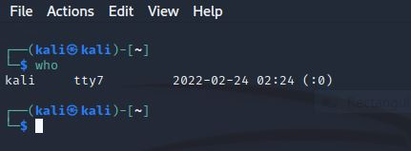

**Options of who command**

a) who -b

**Description:** shows time of last system boot

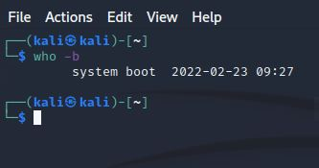

b) who -H

**Description:** print line of column heading

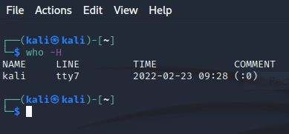

c) who -q

**Description:** will show all login names and number of users logged on

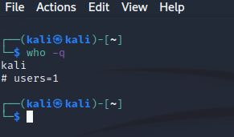

d) who -a

**Description:** will show current user

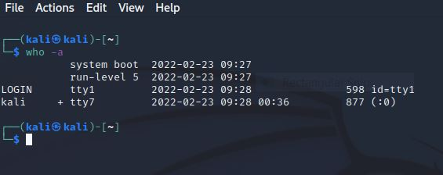

**2) whoami Command**

**Description:** It displays the username of the current user when this command is invoked

**Syntax:**  $whomai

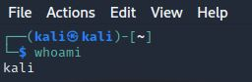

**3) pwd Command**

**Description:** pwd (Print Working Directory) command displays your location currently you are working on.

**Syntax:**  $pwd

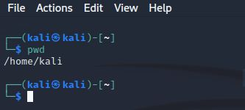

**4) users Command**

**Description:** It is used to show the user names of users currently logged in to the current host. It will display who is currently logged in according to FILE

**Syntax:**  $users [OPTION]... [FILE]

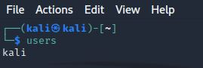

**Options of users command**

a) users --help

**Description:** This option will display the help message and exit

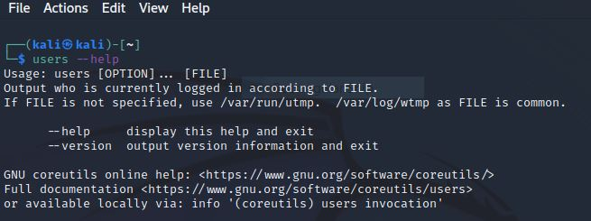

b) users --version

**Description:** This option will show the version information and exit

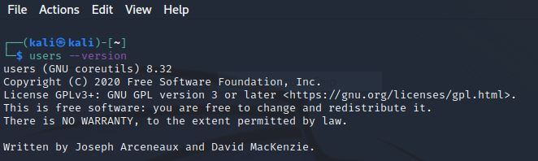

**5) cd (Change Directory) Command**

**Description: The cd command is used to change the current directory (i.e., the directory in which the user is currently working**

**Syntax:**  $ cd [directory]

**To move inside a subdirectory:** $ cd [DIRECTORY_NAME]

**Options of cd command**

a) cd ..

**Description: Change the current directory to parent directory**

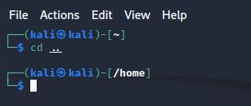

b) cd ~

**Description: Move to user’s home directory to anywhere**

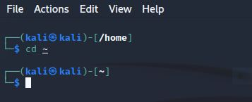

c) cd Desktop/

**Description: Change from current working directory to Desktop**

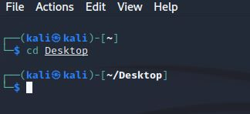

**d) cd ../Downloads**

**Description: If we are currently in /home/Kali/Desktop then we would be placed in home/kali/Downloads**

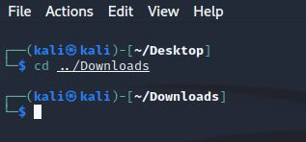

**6) ls Command**

**Description:** The ls command is used to list files or directories in Linux and other Unix-based operating systems.

**Syntax:**  ls [OPTIONS] [FILE|DIRECTORY]

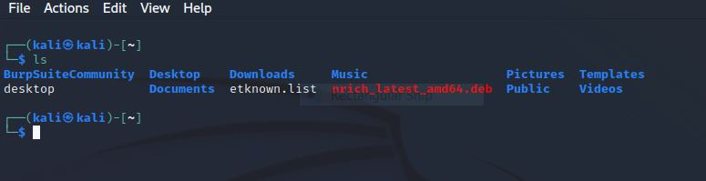

**Options of ls command**

a) ls -l command

**Description:** To show long listing information about the file/directory

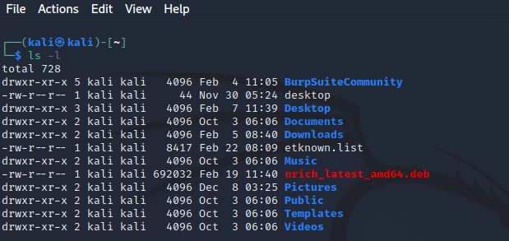

b) ls -a

**Description:** List all files including hidden files starting with ‘.’

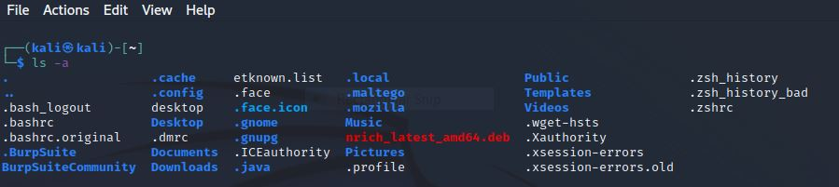

c) ls -r

**Description:** List in reverse order

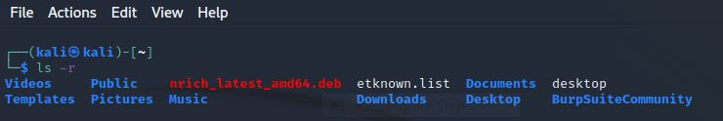

d) ls -t

**Description:** Sort by time and date

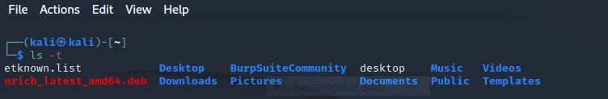

e) ls -s

**Description:** Sort by file size

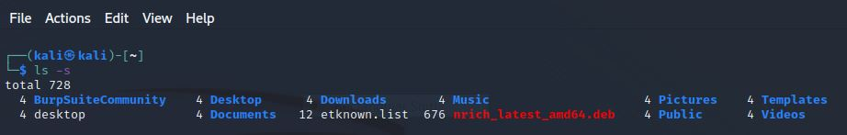

**7)** **echo Command**

**Description:** Display a line of text/string on standard output or a file

**Syntax:**  **echo [OPTION] [STRING]**

**Displaying a text/string**

**Syntax: echo [STRING]**

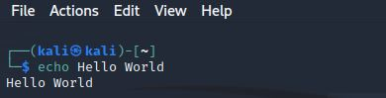

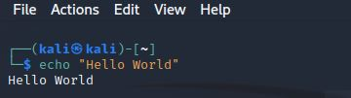

**Options of echo command**

**NOTE: -e** here enables the interpretation of backslash escapes

a) \b

**Description:** It removes all the spaces in between the text

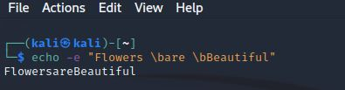

b) \c

**Description:** Suppress trailing new line with backspace interpreter ‘-e’ to continue without emitting new line

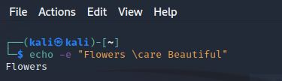

c) \n

**Description:** This option creates new line from where it is used

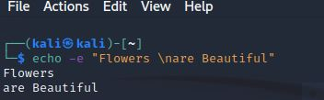

d) \t

**Description:** this option is used to create horizontal tab spaces

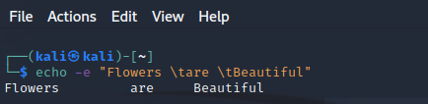

e) \r

**Description:** carriage return with backspace interpreter ‘-e‘ to have specified carriage return in output

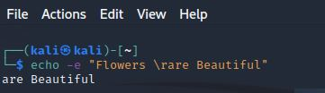

f) \v

**Description:** This option is used to create vertical tab spaces

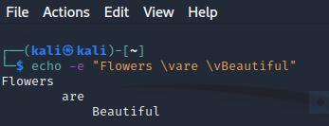

g) \a

**Description:** alert return with backspace interpreter ‘-e’ to have sound alert

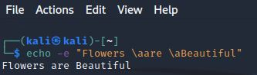

h) echo -n

**Description:** This option is used to omit echoing trailing newline

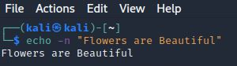

**8) cal Command**

**Description:** **cal** command is a calendar command in Linux which is used to see the calendar of a specific month or a whole year

**Syntax:** cal [ [MONTH] YEAR]

**Options of cal command**

a) cal / cal -1 (Default)

**Description:** Shows current month calendar on the terminal with the current date highlighted

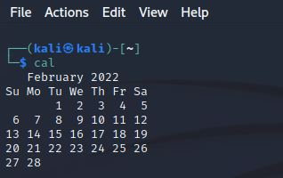

b) cal -3

**Description:** Displays three months spanning the date or we can say shows the calendar of previous, current and next month

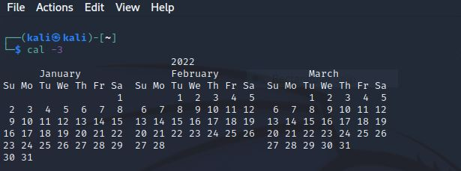

c) cal -m

**Description:** Display Monday as the first day of the week

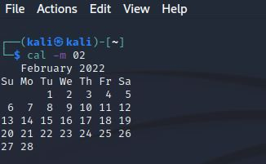

d) cal -j

**Description:** Use Day-of-year numbering for all calendars These are also called ordinal days and Julian dates. Ordinal’s days range from 1 to 366

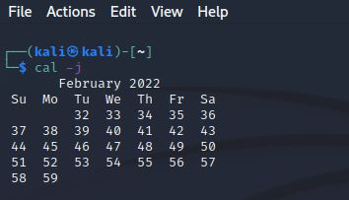

e) cal -y

**Description:** Display a calendar for the current year

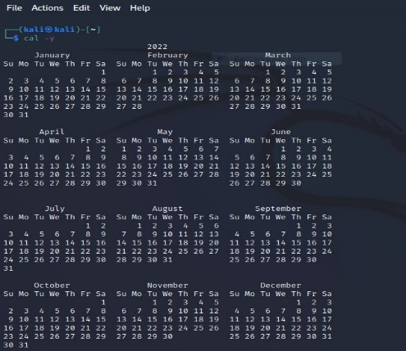

**9) date Command**

**Description:** Print or set the system date and time

**Syntax:** date [OPTION]... [+FORMAT]

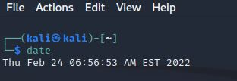

**Options of date command**

a) date +%a

**Description:** The abbreviated weekday name

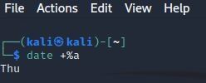

b) date +%B

**Description:** The full weekday name

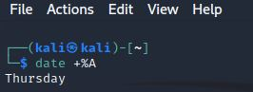

c) date +%b

**Description:** The abbreviated month name

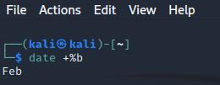

c) date +%B

**Description:** The full month name

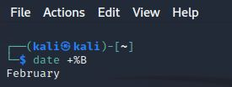

d) date +%w

**Description:** Day of week (0….6); 0 is Sunday

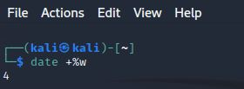

e) date +%d

**Description:** Display the day of the month (01 to 31)

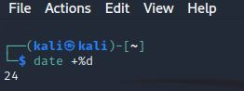

f) date +%D

**Description: Display date as mm/dd/yy**

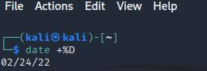

**g) date +%m**

**Description:** Displays the month of year (01 to 12)

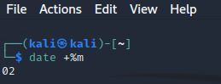

**h) date +%y**

**Description:** Displays last two digits of the year (00 to 99)

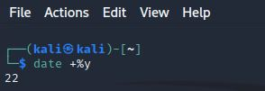

**i) date +%T**

**Description:** Display the time in 24-hour format as HH:MM: SS

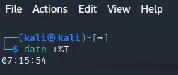

**10) cat Command**

**Description:** It reads data from the file and gives their content as output. It helps us to create, view, concatenate files.

**Syntax:** cat [OPTIONS] [FILENAME]

**Options of cat command**

**a) cat filename**

**Description:** It will show content of given filename

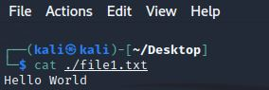

**b) cat -b**

**Description:** Omits line numbers for blank space in the output

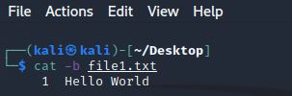

**c) cat -E**

**Description:** Displays a $ (dollar sign) at the end of each line

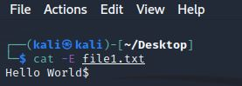

**d) cat -n**

**Description:** It will show content with line number

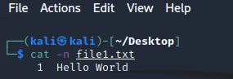

**e) To view multiple file**

**Description: This will show the content of file1 and file2**

**Syntax: $cat file1 file2**

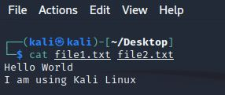

**f) Create a file**

**Description: will create new file**

**Syntax: $cat > filename**

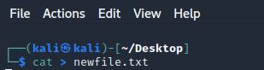

**g) Copy the contents of one file to another file**

**Description: The content will be copied in destination file**

**Syntax: $cat** [filename-whose-contents-is-to-be-copied] > [destination-filename]

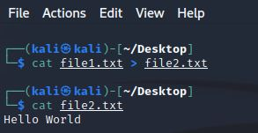

h) **cat -s**

**Description: will suppress repeated empty lines in output**

**Syntax: $cat -s filename**

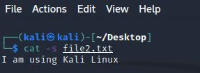

i) **append through cat Command**

**Description: will append the content of one file to the end of another file**

**Syntax: $cat file1 >> file2**

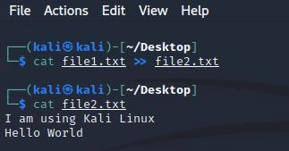

**j) tac Command**

**Description: will display content in reverse order**

**Syntax: $tac filename**

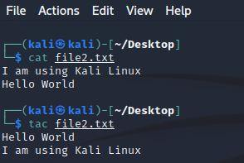

**k) cat Command to merge contents of file**

**Description:** Will merge the contents of file in respective order and will insert that content in “merged_filename”

**Syntax:** $cat "filename1" "filename2" "filename3" > "merged_filename"

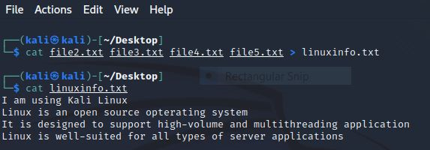

**11) man Command**

**Description: man command is used to display the user manual of any command that we run on the terminal**

**Syntax: $man [OPTION] .... [COMMAND NAME]**

**Options and command name of man command**

a) man man command

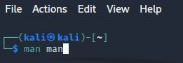**Description: It displays the whole manual of the command**

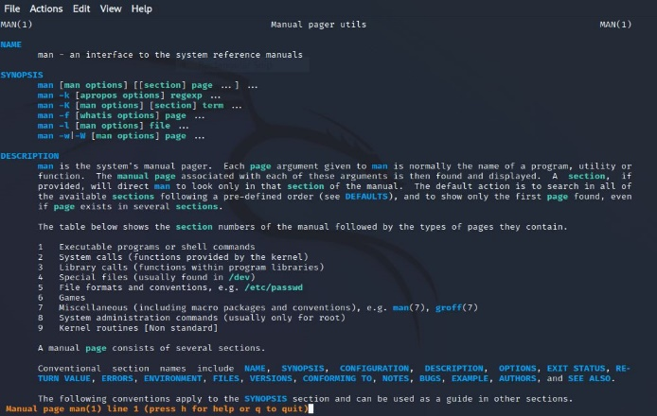

b) man printf

**Description: It displays the whole manual of the command**

**Example: $man printf**

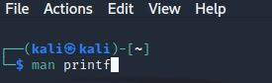

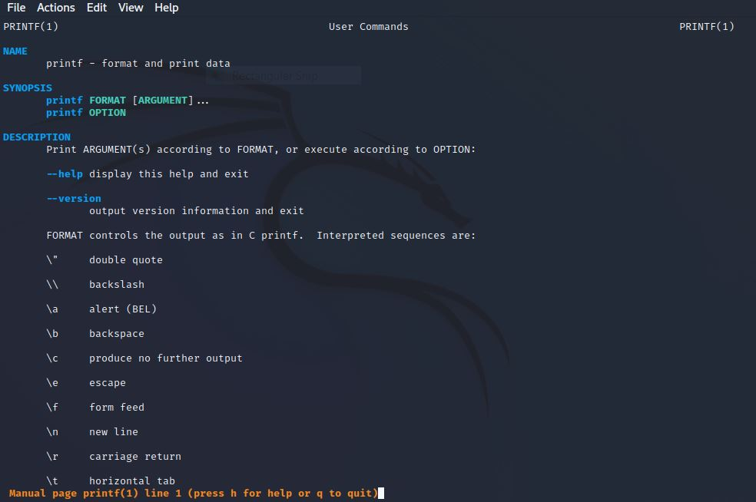

c) -f option

**Description:** This option gives the section in which the given command is present

**Example: $man -f ls**

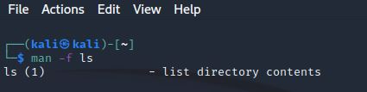

d) -a option

**Description:** This option helps us to display all the available intro manual pages in succession

**Example: $man -a intro**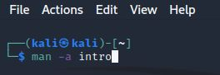

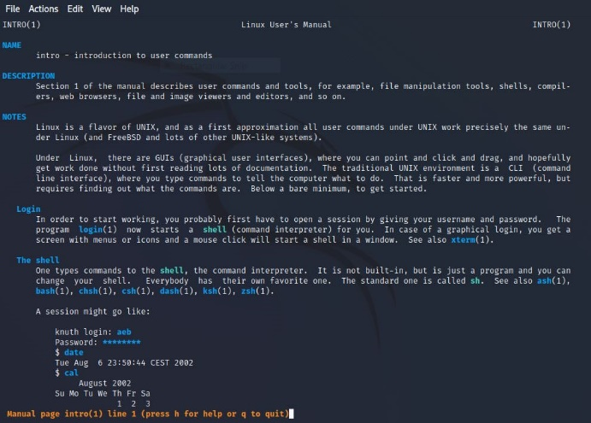

**e) -k option**

**Description:** This option searches the given command as a regular expression in all the manuals and it returns the manual pages with the section number in which it is found

**Example: $man -k cd**

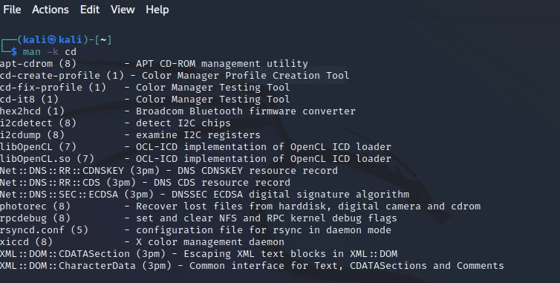

f) -w option

**Description:** This option returns the location in which the manual page of a given command is present

**Example: $man -w ls**

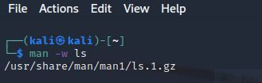

**g) -I option**

**Description:** It considers the command as case sensitive

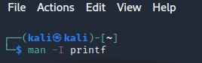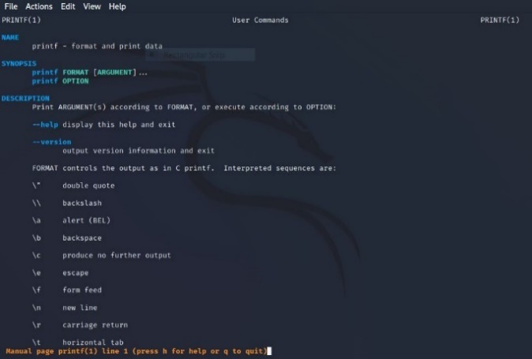**Example: $man -I printf**

**12) clear Command**

**Description:** It is used to clear the terminal screen

**Syntax: $clear**

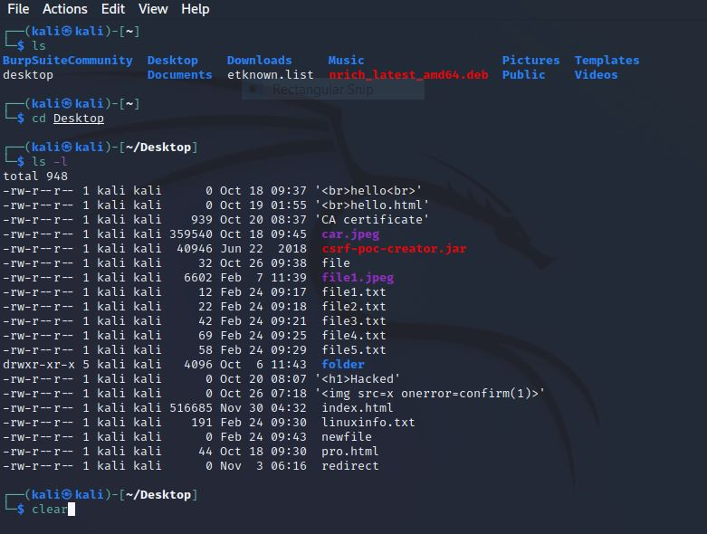

**13) mkdir Command**

**Description: mkdir** command allows the user to create directories (also referred to as folders in some operating systems). This command can create multiple directories at once as well as set the permissions for the directories

**Syntax:** mkdir [OPTIONS...] [DIRECTORIES ...]

